Research Report
Prepared by Chana Roger
Date: November 15th, 2021

Abstract
The contents of this report consist of the design of a recreation centre in Pemberton, BC. It also incorporates an understanding of the limitations and requirements surrounding the overall process. Included in the report is an insight of universal design and accessibility and how they can be integrated into a public facility. A conceptual plan was created based on universal design practices and accessibility requirements. Similar case studies were compared, and common design practices were incorporated to generate a schematic design of a facility for the public to gather. The facility’s aim is to benefit the village both socially and economically through practical design. Public facilities will always be required in any community. The importance, however, is how practical and functional the actual building is. This project was created to ensure the facility will have a positive impact on the community through accessibility.

Contents

1. Introduction 5
2. Background/Context 5
2.1. Recreation Centre Benefits 5
2.2. Accessibility 5
2.3. Universal Design 5
2.4. Safety 5
3. Methodology 6
4. Discussion 6
4.1. Design Precedents 6
4.2. Design Layout 7
4.2.1. Accessibility 11
4.2.2. Aesthetics 12
5. Conclusion 14
6. Recommendations 14

Lists of Tables and Figures

Figure 1 – Entry Amenities 7
Figure 2 – Skating Rink 8
Figure 3 – Aquatics Centre 9
Figure 4 - Gymnasium 9
Figure 5 – Site Plan 10
Figure 6 – Floor Plan 10
Figure 7 – Parking Lot 3D View 11
Figure 8 – Entrance to the Building 13
Figure 9 – North-East Gymnasium Glazing 13
Figure 10 – South-East Aquatics Centre Glazing 13
Figure 11 – Glazing into Aquatics Centre 16
Figure 12 – Front View 16

Introduction
A recreation centre holds a significant purpose in a community because it brings people together to gather, socialize or exercise. The village of Pemberton, BC is a close-knit community that does not have a recreation centre. The addition of this type of public facility would serve Pemberton both socially and economically. The objective for this design project is to design a facility that will create this much needed space for people to come together for the improvement of the village. This report establishes the benefits an activity centre has on the community of Pemberton and presents a design for Pemberton as a feasible way to incorporate accessibility, aesthetic, and comfort into a multi-use building.

Background/Context
This design for a recreation centre applies best practice principles of public design, with an emphasis on universal design, accessibility, and safety.

Recreation Centre Benefits
Recreation centres provide several benefits socially and economically, as well as improves personal physical health. Offering a variety of activities promotes exercise by providing an affordable and convenient place for people to focus on their fitness goals [1]. In addition, community centers provide a safe place for young people to hang out, make new friends, and stay out of trouble [1]. A recreation centre facility creates an opportunity for local revenue through activities or events. In addition, a quality recreation centre is a valuable asset to any community [2].

Accessibility
The new facility is designed to ensure the site can be easily accessible no matter the mode of transportation. This has been done by including ground level parking, entrances, and walkways. Accessibility has been incorporated into the design to bring the community together, and in turn, meet the needs of all ages and abilities [3].

Universal Design
Similarly, incorporated into the design are the principles found in universal design. As stated in “Universal Design 101”, universal design is the structure of an environment that can be accessible to the greatest extent possible regardless of age or ability [4]. This design practice was incorporated into the project to provide a simple and intuitive use [4], that is efficient and safe.

Safety
Another significant factor included in the design is safety. This was achieved by incorporating a high standard for accessibility, which stems from universal design. Similarly, a recreation centre provides the necessary facilities to keep youth safe [2]. Accessibility was a focus for the design, as it is required by the BC Building Code for all public buildings [5], but universal design was included to ensure the design meets a higher standard to support the whole community and form a safer, more welcoming facility.

Methodology
The design was created using Revit software, and the rendering images included in the report are created with Twinmotion software. The design follows the 2018 British Columbia Building Code [5] and the Pemberton Zoning Bylaws [6] to ensure the building is feasible. Principles of universal design and accessibility were applied to the design of building access and traffic flow. The building has one main entry, with multiple exits for safety. The property is located at the corner of two streets, which provides two vehicle entries and exits to the site. This minimizes congestion and contributes to traffic flow and migration of people. In addition, the building has been strategically placed to accommodate for the site features such as existing roads, fields, and infrastructure.

Discussion
This is an overview and understanding of worldwide case studies that reflect similar requirements as the project noted in this report. The first section revolves around design precedent facilities, and how the planning correlates to this project. The second section contains facilities that incorporate many universal design principles and how they connect to the proposed recreation centre in Pemberton.

Design Precedents
The design of this project is based on other precedent facilities across North America. Recreation and activity centres are all public spaces that contain similar requirements. Incorporating concepts from other case studies is a feasible way to achieve a practical design and it has been included for several aspects throughout the design of the recreation centre for Pemberton, BC.
The most significant case study is the West Coast Multiplex in Tofino, BC, as it is a local project with similar guidelines and restrictions. This project was developed for the scattered communities on the West coast of Vancouver Island to support and engage the community. Like this project, its objective remained to develop a recreational facility to serve the growing needs of the associated communities [7]. This case study had an impact on the project as it had relatable requirements. Both the Multiplex facility in Tofino and this proposed project are facilities in the making and include the most popular and used amenities for a small community. The West Coast Multiplex split the facility into phases. The first phase included the skating arena, while the second included a swimming pool. This is like this project, as the basis for the design included in this report was a skating arena. The next step for the design was to incorporate a swimming pool, and with these two amenities in mind, the facility was designed. The West Coast Multiplex is an ideal facility for uniting families and communities as well as contributing to improve health and wellness through a variety of recreational and educational activities [7]. Given these guidelines, the West Coast Multiplex recreational facility was a major precedent piece for this project. The recreation centre designed for Pemberton, BC was designed to promote health through activity.
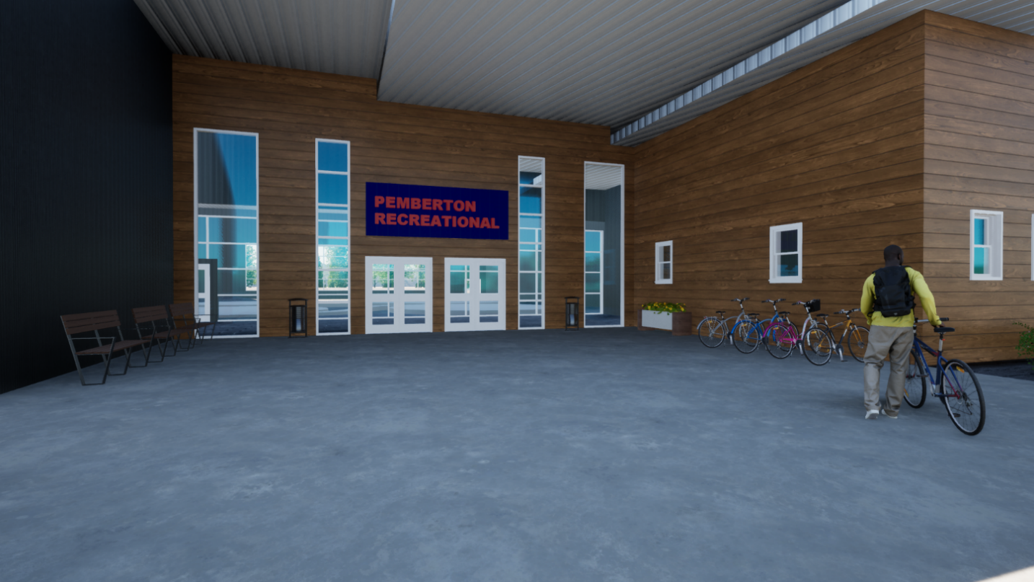
Similarly, the proposed design incorporates the key attributes included in the Vermont precedent building. The four key attributes reflected in the design include accessibility, activities, comfort, and sociability [8]. These elements have also been integrated in the proposed design in reflection to this case study. In the Vermont case study, the planners included exterior uses in the design such as benches, bike racks, plantings, and a place to tie up waiting dogs. In turn, bike racks, planters and benches were incorporated into this recreation centre design at the entrance to the facility. this is shown in Figure 1 below.
Figure 1 – Entry Amenities

Universal Design Precedents

Design Layout
The design has been created to include a variety of activities within the facility. The main uses of the building include a skating arena, aquatics centre, and a gymnasium, along with their associated amenities. This is shown in Figure 2, Figure 3, and Figure 4, respectively. A major focus for this project revolves around accessibility; however, it is also designed to be aesthetically pleasing. With these two in mind, a feasible design layout has been created. Figure 5 contains a site plan, and Figure 6 is a floor plan of the building for reference throughout the report.
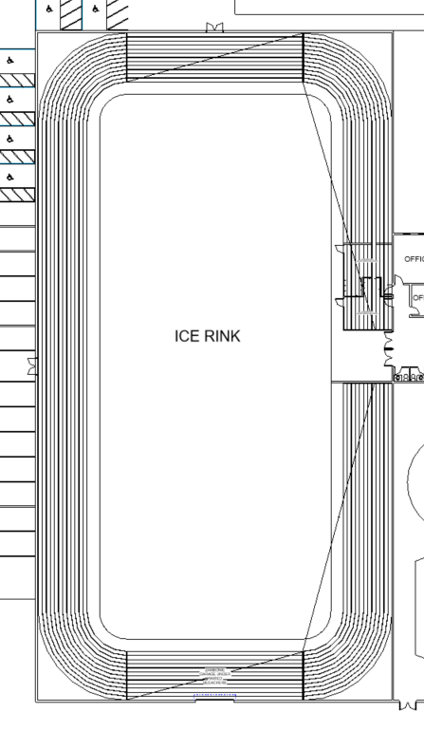
Figure 2 – Skating Rink
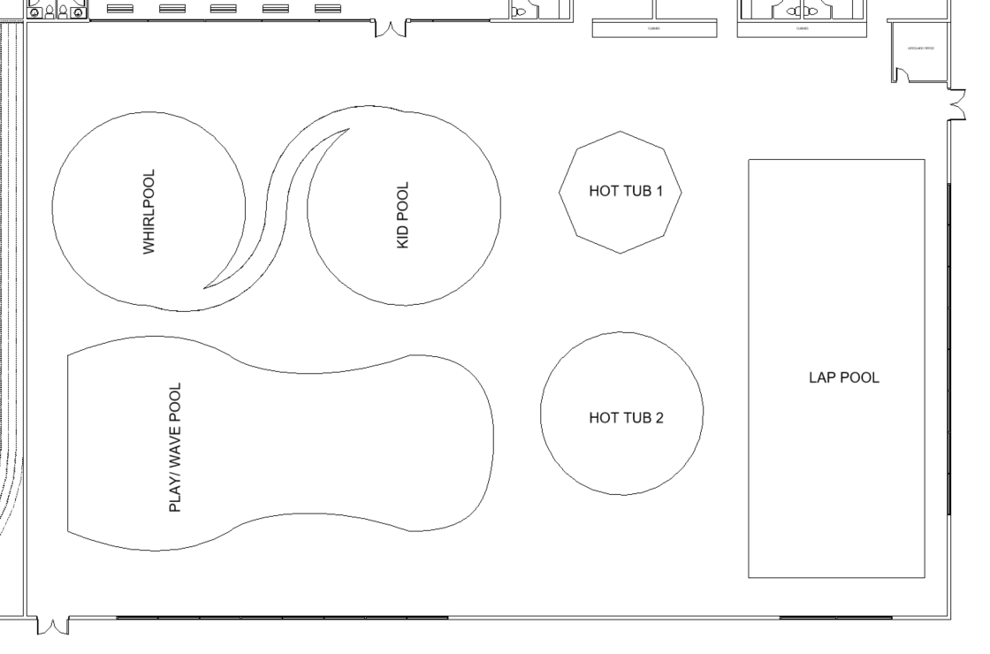
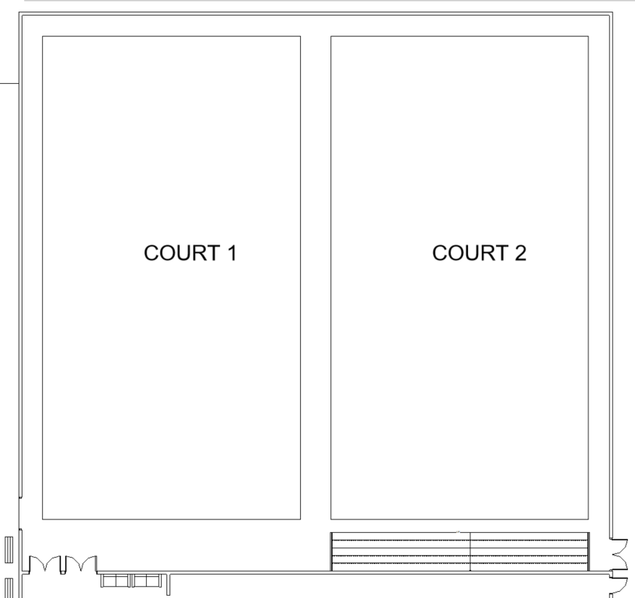
Figure 3 – Aquatics Centre
Figure 4 - Gymnasium
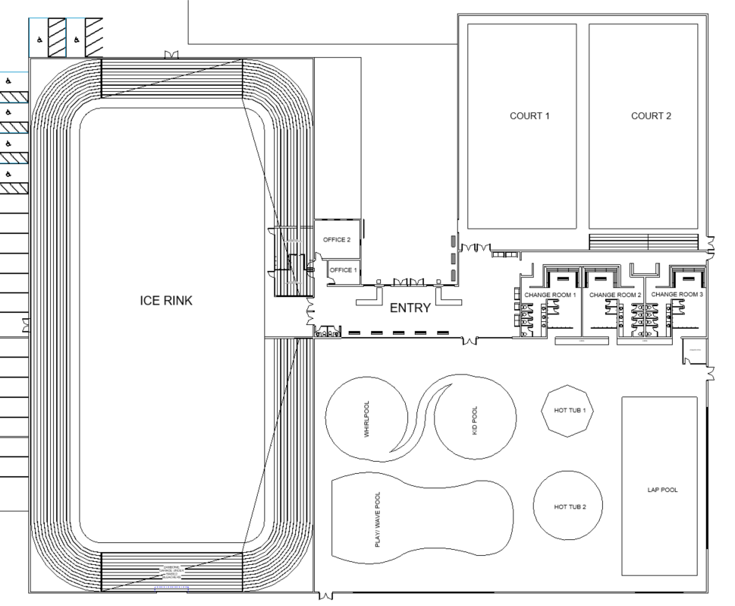
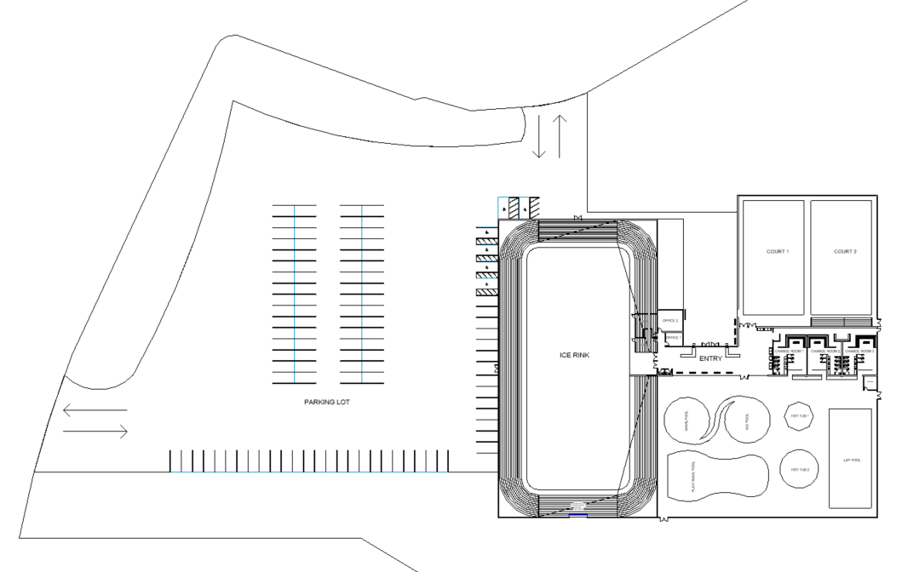
Figure 5 – Site Plan

Figure 6 – Floor Plan

Accessibility
The entrance to the building is located on the north of the lot, between the two sides of the building. This provides an alcove entrance for users that will remain covered by an extended roof overhang. By providing the entrance in the middle of the building, the public has quicker access to any activity within the building as they are all near the entrance. Upon entry, the reception front desk is easily accessible for checking in or directions. This provides a form of universal design, as it is an opportunity for any individual to enter the facility and be assisted to participate in any activity. Similarly, the entrance way and common area is very open and spacious to provide a feasible amount of space. This is an aspect of universal design, as it surpasses the minimum level of accessibility required by the British Columbia Building Code [9].
The building is a single story, meaning all services are located on the ground level to ensure accessibility. Although elevators are a practical way to ensure wheelchair accessibility, it is very costly. Rather than producing a multi-level building, the design has been created to use more lot coverage and remain on one level. Considering the site is quite large, this was the most valuable design for accessibility as well as budget and time. Two exits have been provided within each closed room of the facility in case of an emergency. This is a requirement from subsection 3.4.2.1. of the 2018 British Columbia Building Code [5] and has been incorporated accordingly.
On the west side of the plan, the skating arena contains one rink with partial elevated bleacher seating for spectators, as noted in Figure 6 above. The seating is raised up roughly eight feet to offer change rooms, Zamboni storage, and safe exits. The bleachers are also pushed pack to offer accessible space for spectators.
Six accessible parking stalls are included in the parking lot design, located at the closest point to the entrance. The parking lot consists of two entrances and exits for easy access and flow of traffic, as shown in the floor plan above. Figure 7 is a 3D view of the new proposed accessible pathway. This has been included to visualize the exterior accessible routes from parking to the building entrance. In addition, Figure 8 shows that the interior pathways are accessible from any location.
Accessibility played a major role in this project, but universal design was actively impacting design decisions. Subsection A-3.8.2.2. states it is required by code that entrances are 50% accessible [10], but within this design, all entrances and exits are accessible. This has been done by ensuring the walkways and entrances are level both access to and inside the facility. In addition, from subsection A-3.8.2.5., the code requirement for accessible parking stalls is 1 for every 100 regular stalls [10]. With the proposed parking design, there are 99 regular stalls and 6 accessible stalls. This is a form of universal design, as it goes above the minimum requirement to ensure the facility is welcoming to the whole community regardless of ability. Multiple accessible washrooms are provided within the facility. There are 2 accessible washrooms provided within the entry of the building, as well as one located in each change room on the east side of the facility. Multiple accessible washrooms, large walkways, several handicap parking stalls, and ground level accessibility are the most valuable forms of universal design within the project, as they reach a maximum level of accessibility and go further than what is required by code.
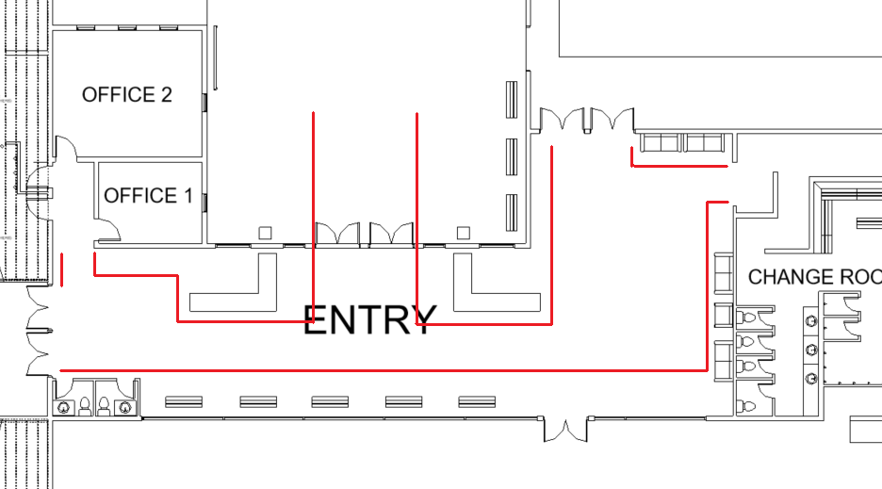
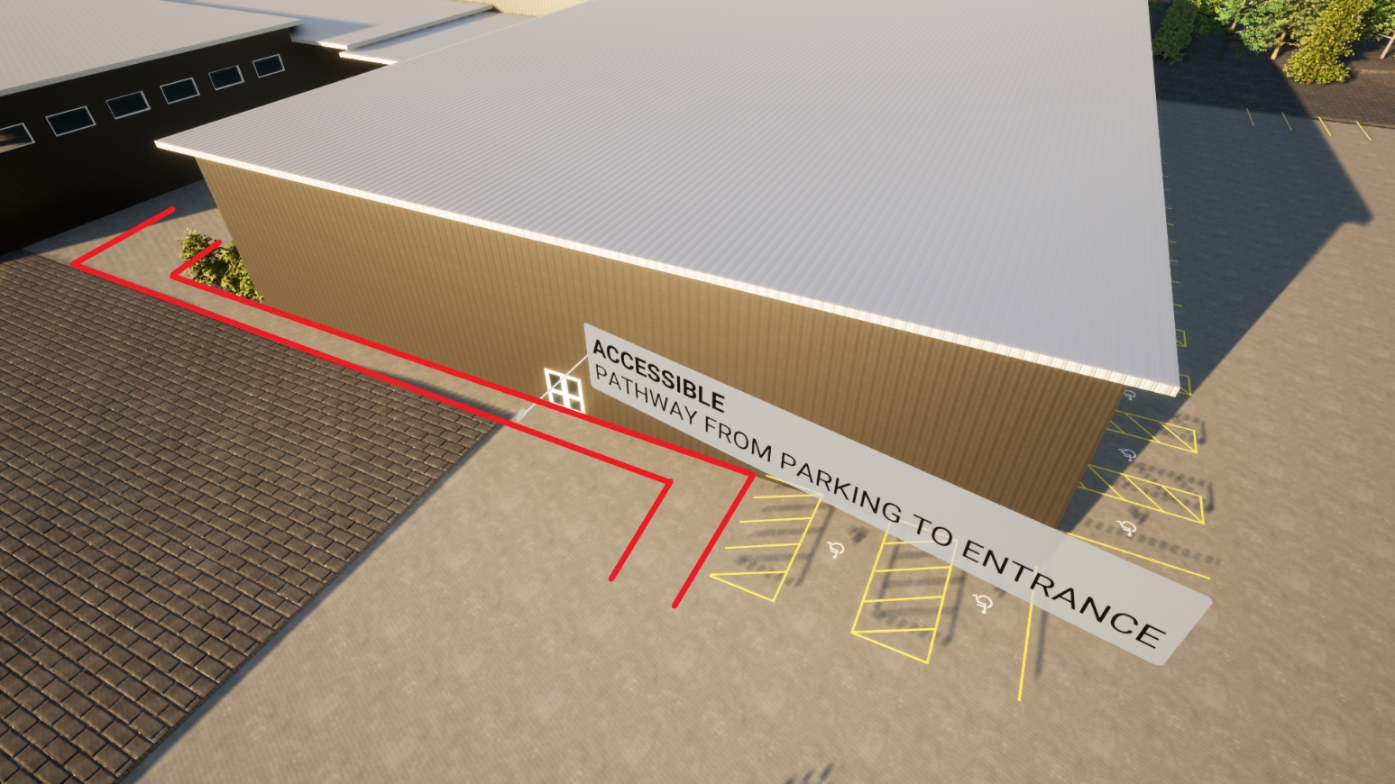
`
ACCESSIBLE PATHWAY FROM ENTRANCE INTO BUILDING
Figure 8 – Plan of Interior Accessible Path
Figure 7 – 3D of Accessible Path

Aesthetics
Although accessibility is a crucial aspect to the project, the overall look of the facility also played a role in the design. While the building is spacious for accessibility, it was also designed for ease of use. Personal space is an important aspect to feeling comfortable in a public setting. This has significantly increased due to the COVID-19 outbreak and will carry on post-pandemic [11]. Because of this, a large entryway as well as walking spaces have been provided for a safe and welcoming environment.
On top of this, entry windows and glazing has been incorporated for a bright environment, as shown in Figure 8. Similarly, a curtain wall between the common area and aquatics centre has been added to the design as shown in Figure 11 in the Appendix. This allows spectators to safely observe the pools without entering the swimming area. The plan is designed so that the kid’s pool is located closest to the windows to offer parental figures the ability to keep watch of their children while they take part in activities. Although the design is not limited to specific materials, the rendered images include exterior cladding for visual appeal. Horizontal wood cladding is used at the entrance of the building for a unique and interesting entrance. The remaining areas of the building are finished with grey corrugated steel. In addition, all window and door trim are white, to contrast the darker siding.
Large windows have been incorporated into the separate uses in the building for natural light. Figure 9 shows the high windows located on the north and east side of the building that offer light into the gymnasium. Similarly, large curtain wall windows are displayed in Figure 10 along the south and east side of the building, accentuating the pools. Providing windows and large hallways that comfortably connect the different uses within the building has resulted in a spacious, bright, and welcoming facility.

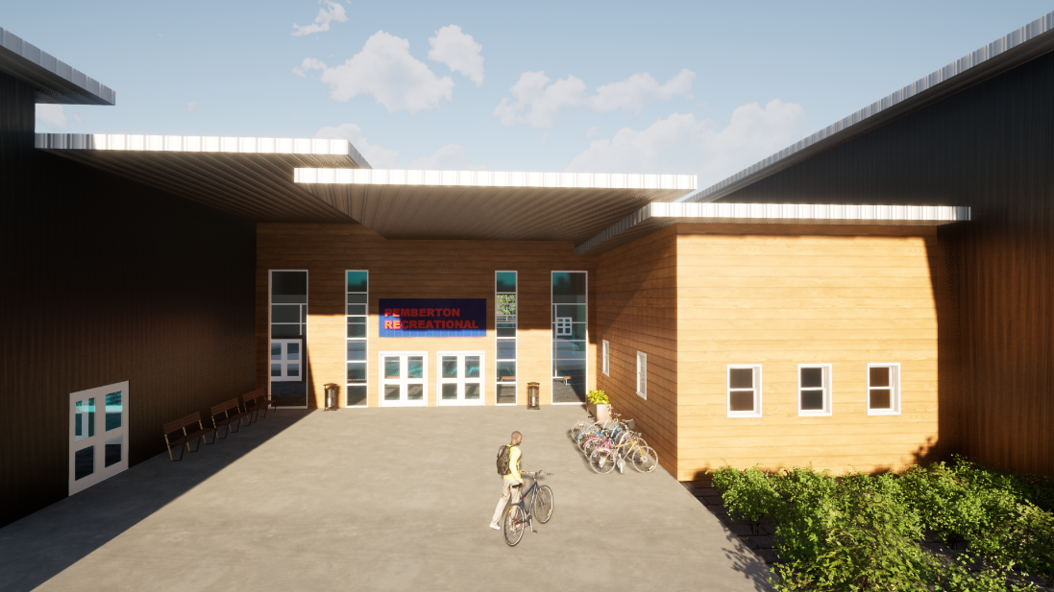

Figure 9 – Entrance to the Building
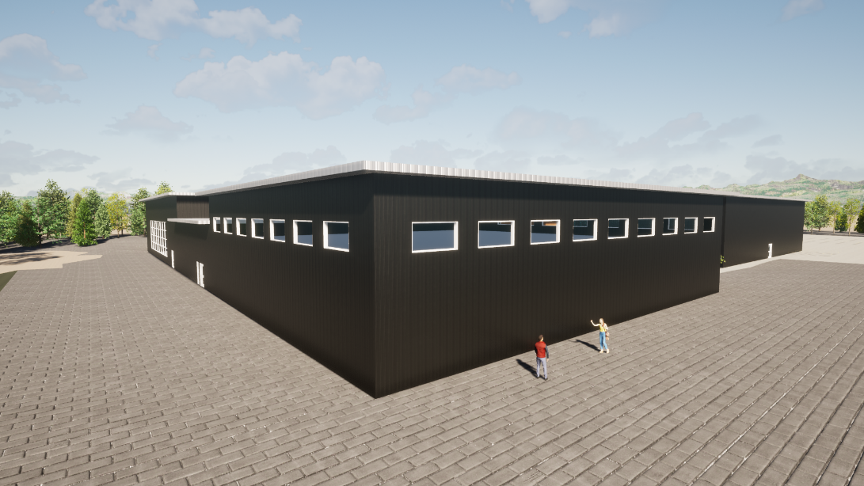

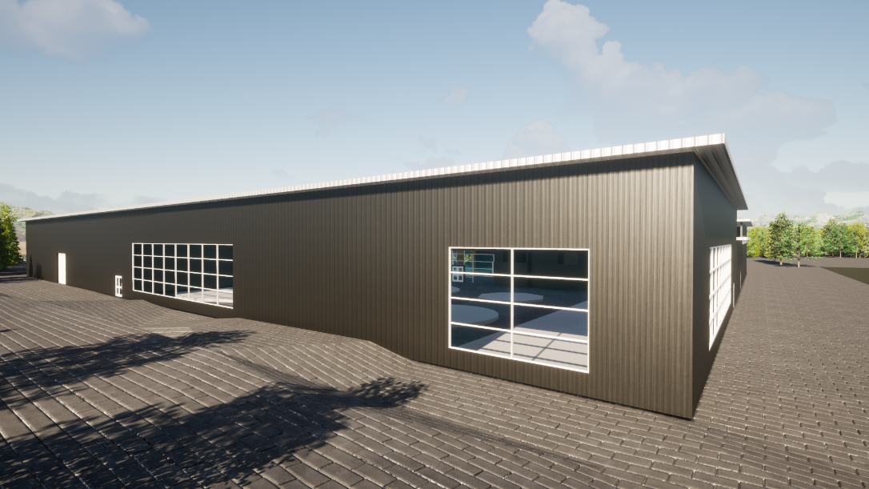
Figure 10 – North-East Gymnasium Glazing

Figure 11 – South-East Aquatics Centre Glazing

Conclusion
This recreation centre design has been created to generate a welcoming, useful building for the community. Similarly, it follows the notion that states, “a community recreation centre can foster community pride and bring people together” [2]. This has been achieved through combining ideas and guidelines from similar case studies, integrating universal design, and developing a unique plan that is practical. In addition, the public will benefit from access to an indoor space that contains a variety of activities. The significance of this kind of public building in a small town is immense, as it attracts and keeps families who desire an active lifestyle [7]. As mentioned in the beginning of this report, this is beneficial to the economy in the town as it increases the local population and, in turn, increases revenue. The use of accessibility as well as universal design techniques within the proposed plans impose a welcoming environment that is understood by all ages and abilities [4]. The proposed building design for a recreation centre has incorporated accessibility, universal design, and unique design practices to create an engaging public space that is safe, welcoming, and feasible.

Recommendations
Due to limited time, incorporating other uses within the building was avoided. This facility could include a second level for a workout gym, or an underground level to incorporate a climbing gym, which would increase revenue and usage. In addition, further design implements were not included such as materials, furniture, and lighting. The design, however, was created as a precedent piece to explain the benefits of a community centre in Pemberton, BC. In relation, this report could benefit other small, rural communities that are lacking amenities, as it highlights the importance of a community centre, and how it can be achieved. Based on the research explained and the studies found, the village of Pemberton would greatly profit from the addition of a recreation centre. As stated in the report, by creating an accessible, welcoming facility, the community gains the opportunity to benefit socially and physically through the facility and associated activities. In addition, the town’s economy would prosper by the additional infrastructure as well as entice the public to engage in the town’s growing amenities.
References

[1] | T. S. F. Company, "How a Community Center Benefits a Small Town," Improving Communities Through Sport, 12 February 2018. [Online]. Available: https://sportsfacilities.com/community-center-benefits-small-town/. [Accessed 12 October 2021].
[2] | Jumpsix2, "The positive Impact of Community Recreation Centers," The Sports Facilities Companies, 9 March 2016. [Online]. Available: https://sportsfacilities.com/the-positive-impact-of-community-recreation-centers/. [Accessed 28 October 2021].
[3] | "Guiding Principles," 2021. [Online]. Available: https://vancouver.ca/docs/planning/little-mtn-open-house-info-board-guiding-principles.pdf. [Accessed 9 March 2021].
[4] | S. Woodward, "Universal Design 101," Rick Hansen Foundation, 2021. [Online]. Available: https://www.rickhansen.com/news-stories/blog/universal-design-101. [Accessed 10 March 2021].
[5] | G. o. B. Columbia, British Columbia Building Code, Province of British Columbia, 2018.
[6] | V. o. Pemberton, "Zoning in the Village of Pemberton," 20 October 2020. [Online]. Available: https://www.pemberton.ca/departments/development-services/zoning. [Accessed 14 July 2021].
[7] | "Building a Recreational Facility," West Coast Multiplex, 2021. [Online]. Available: https://westcoastmultiplex.org/. [Accessed 11 February 2021].
[8] | P. f. P. Spaces, "Turning Public Buildings into Community Anchors," 1 January 2009. [Online]. Available: https://www.pps.org/article/11principles. [Accessed 16 August 2021].
[9] | J. M. a. M. Ranahan, "Beyond Accessibility to Universal Design," WBDG- Whole Building Design Guide, 2021. [Online]. Available: https://www.wbdg.org/design-objectives/accessible/beyond-accessibility-universal-design. [Accessed 11 March 2021].
[10] | P. o. B. Columbia, "Building Accessibility Handbook," 2018. [Online]. Available: https://www2.gov.bc.ca/assets/gov/farming-natural-resources-and-industry/construction-industry/building-codes-and-standards/guides/2020_building_accessibility_handbook.pdf. [Accessed 14 November 2021].
[11] | C. S. H. Laboratory, "MedRxiv.org," Health Science, 12 June 2021. [Online]. Available: https://www.medrxiv.org/content/. [Accessed 21 September 2021].

Appendices
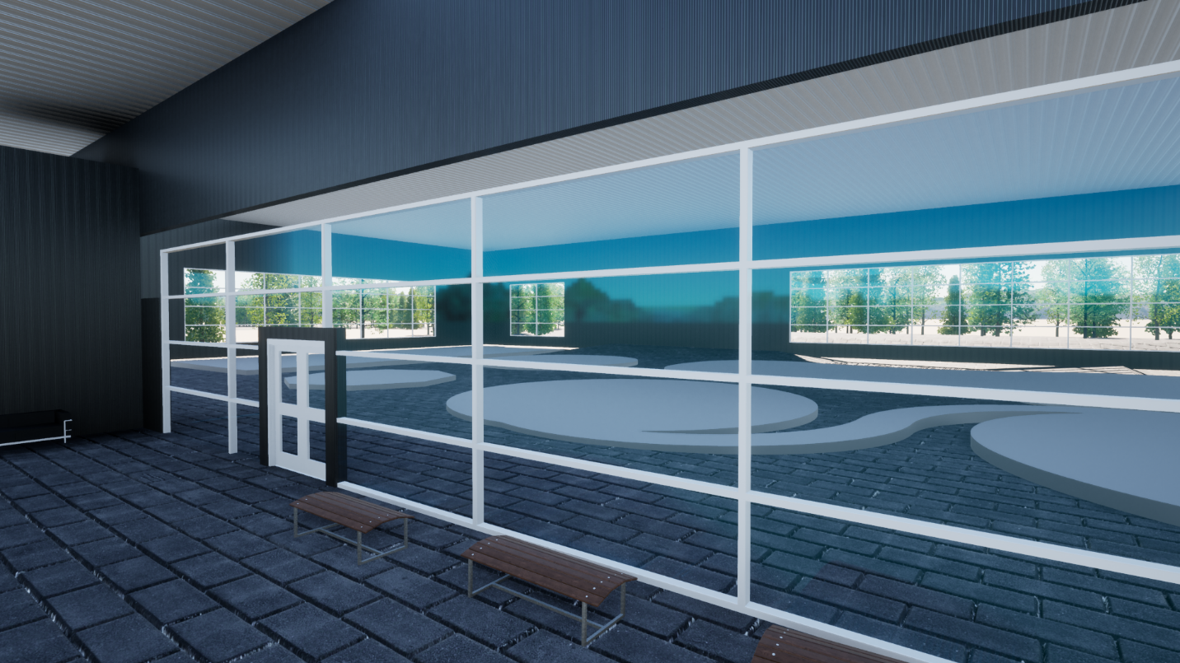
Figure 12 – Glazing into Aquatics Centre
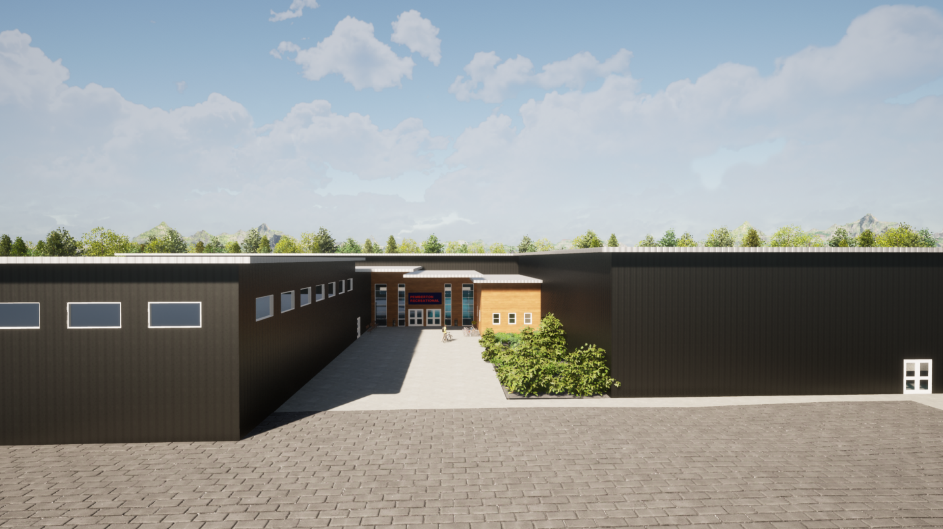
Figure 13 – Front View

